**Mains outage detector**

|  |  |
| --- | --- |
| Author | Abousoufian El ghourri |

Content

1 Introduction 2

2 Material and methods 2

3 Results 5

3.1 5 Main blocks 5

3.2 Way of detecting 5

3.3 Working principle 6

4 Discussion 9

5 Reference list 9

# Introduction

The project is based on an existing project called ‘mains failure detector’ from the magazine ‘*Elektor’*. The detector sends an SMS notification to the user when the mains voltage fail. From the moment the mains voltage is back again, the user also receives an SMS notification. Users on holiday or with a second residence immediately receive a notification when the mains voltage of critical devices fail. This makes it possible to intervene more quickly. The electrical scheme and the component specifications can be copied from the magazine *‘Elektor’*. The paragraph ‘Material and methods’ describes how to order components via the correct footprint. The following chapter ‘Results’ describes both the functionality of the components and the project as a whole.

# Material and methods

The detector consists of passive, active, integrated circuits and connectors as components. For most of the components the existing project offers the specifications about which components need to be used together with the correct way of connecting. The components form a combination of both ‘through hole’ and ‘surface-mounted’ devices.

The PCB design program ‘Altium’ offers via the module ‘manufacturer part search’, a way to look up a component, from which manufacturer it can be obtained and the correct corresponding footprint.

Looking up a component happens via the built-in filter at ‘manufacturer part search’. When the search module has detected the component it shows immediately whether the footprint is available in the Altium library. Thereafter the correct component is ordered from the correct manufacturer. By respecting this way of working, mistakes against the incorrect footprint are minimized.

The below figure shows the Altium program with a search example of a component via “manufacturer part search”:

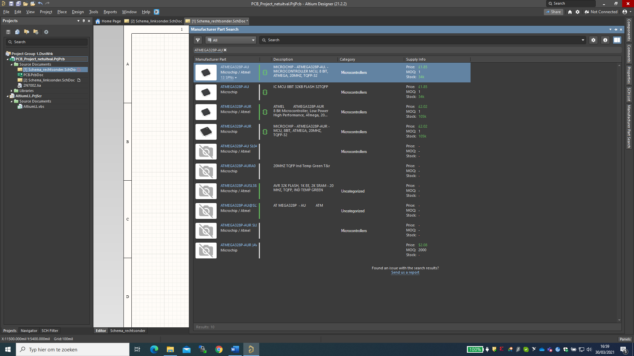

Figure 1: looking up a component via manufacturer parts

If there is a green symbol on the right of the component which looks like an integrated circuit, it means that the footprint is available in the Altium library. Below an example of this symbol:

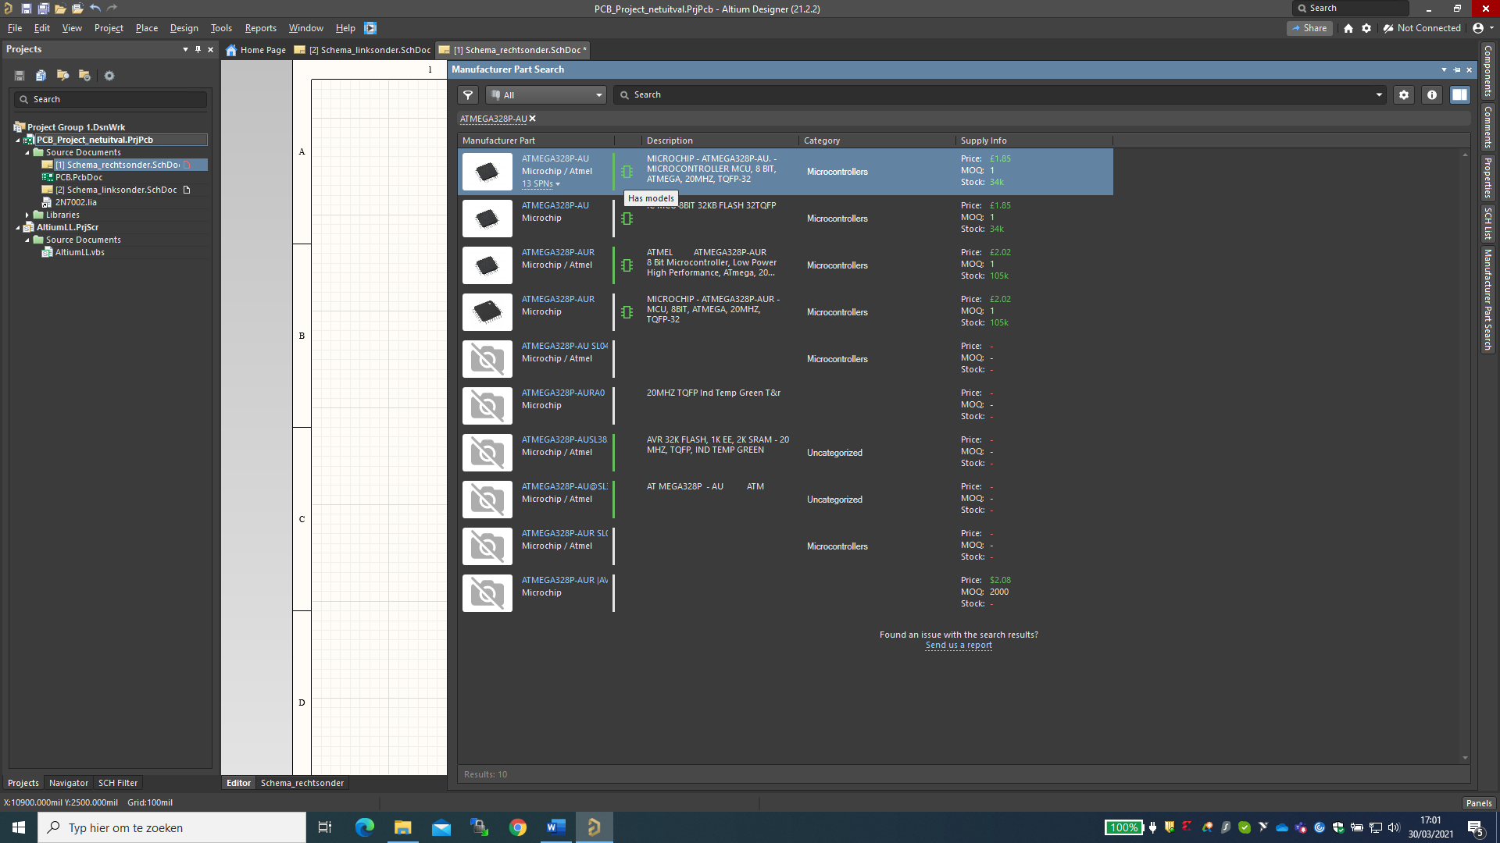

Figure 2: footprint symbol

When there is no footprint available for a component in the Altium library, it is designed via the wizard tool using the datasheet of the specific component. When designing the footprint of one specific component, it is necessary to create both a schematic and a PBC library.

Since the project dates from the year 2018, some components, such as the resonator of Murata are hard to obtain via normal manufacturers. To solve this issue, alternative websites like Ebay are consulted. When ordering each component, the delivery time needs to be taken into account to avoid that the deadline gets compromised. For components where a clear pinout description is missing, datasheets can offer a solution to find out. This will reduce the chance of incorrect electrical connections.

The below table shows a bill of material with the price, name of the manufacturer and the delivery date:

Table 1: billing table of the components

For the PCB design, a case needs to be created. This case will be developed based on predetermined requirements. Compactness, user-friendliness and aesthetics are some of the requirements for the case. Regarding the connection of the mains voltage and the radio frequency antenna, a recess is provided in the case. Thereafter the case will be printed. The program ‘Autocad’ will be used for the design of the 3D-model of the case.

# Results

## 5 Main blocks

The detector consists of five main blocks. The power supply part is directly fed by the mains voltage and will supply all other four blocks with the appropriate DC voltage. When the mains voltage is lost, the power supply is supported by a battery backup that takes over. The detection part responsible for detecting a power failure continuously provides the controller with feedback. This in turn addresses the mobile phone module to alert the user in the event of a power failure. The figure below shows the five blocks. [1]

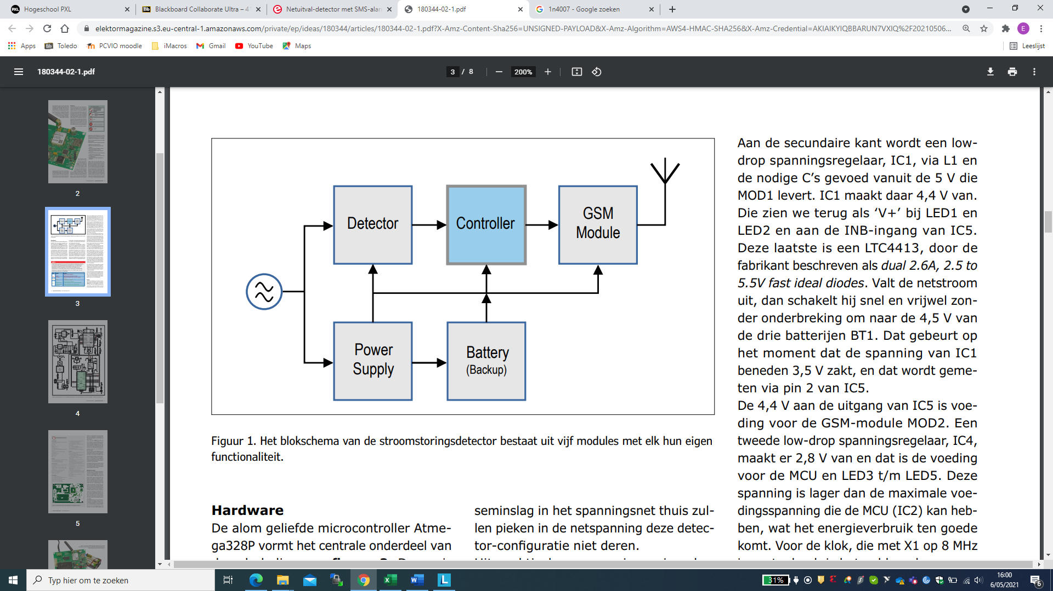

Figure 3: The five main blocks

## Way of detecting

Detecting a power failure is done by looking at the zero crossing of the mains alternating voltage. Every 250 ms is monitored. When the zero crossing fails for the first time, the system will wait another 250 ms for the next zero crossing. Only if a second zero crossings occurs, it is seen by the system as a power failure. This security is implemented to make sure no false alarms will occur. [1]

## Working principle

The figure below shows the electrical scheme and will add value when reading the working principle.

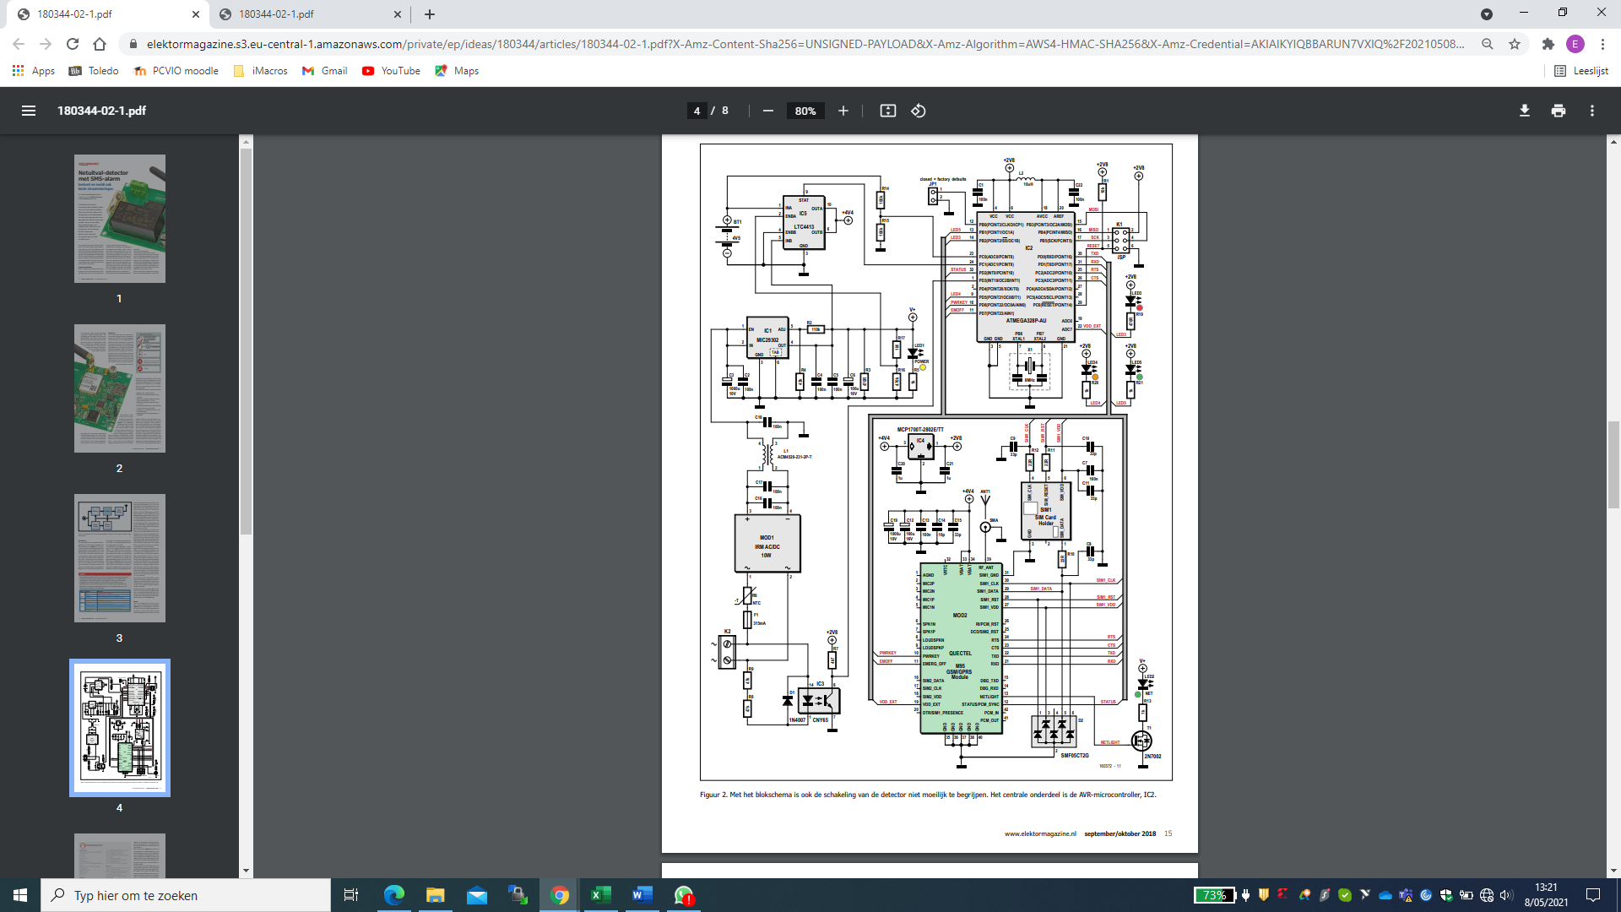

Figure 4: electrical scheme

In the detector section, the positive half of a sine wave from the mains voltage is detected via an optocoupler (IC3). This optocoupler is galvanically isolated with PIN1 of the micro controller unit (IC2), which consists of an Atmega328P. Because the light emitting diode (LED) of the optocoupler can get damaged by the negative half of the mains voltage, this negative half is suppressed by a 1N4007 rectifier diode (D1). [1]

The power supply consists of three main components: a switching power supply AC/DC converter from Meanwell (IRM-10-5) and two low drop voltage regulators. The AC/DC converter (MOD1) converts the high mains voltage to a 5V DC voltage and can be used for both 115Vac and 230Vac. This AC/DC converter is fused with a 10A fuse and is also protected against high inrush currents by an NTC resistor. The AC/DC converter, with a maximum load capacity of 2A, can supply the mobile phone module with high peak currents of 1.6A. These high peak currents from the mobile phone module are necessary in situations where there is a poor mobile coverage. [1]

The first low drop voltage regulator (IC1) will reduce the 5V DC voltage generated by the AC/DC converter to a 4.4V DC voltage. This 4.4 V DC voltage supplies LED1, LED2 and the INB input of IC5 with power. The IC5, which is a “dual 2.6A, 2.5 to 5.5V fast ideal diodes”, will monitor the 4.4V power supply coming from IC1. The moment the power supply drops below 3.5V, a switch will be made quickly and almost without interruption to the backup battery consisting of an external module of 3AA batteries. The backup battery itself is also monitored by PIN23 of the micro controller unit. [1]

IC5 has an output voltage of 4.4V and supplies the GSM module (MOD2) with quectel and a second low-drop voltage regulator (IC4) w [1]ith their power supply. The status of IC5 is requested by PIN24 of the micro controller unit. The second low drop voltage regulator in turn converts the 4.4V to a lower DC voltage of 2.8V. This voltage is used for LED3 to LED5 as well as the micro controller unit (MCU) of Atmega328P and the external 8Mhz clock (X1) of the MCU. [1]

The print consists of a number of LEDs. The table below provides a brief explanation of the status of each LED.

|  |  |  |
| --- | --- | --- |
| **LED** | **STATUS** | **FUNCTION** |
| LED3 | OFF | battery OK or mainoutage |
| BLINKING | battery almost empty |
| ON | battery empty |
| LED4 | OFF | mainoutage |
| BLINKING | AC power available |
| LED5 | OFF | modem not ready or power failure |
| 1hZ BLINKING | modem registered, no number configured |
| 10 Hz BLINKING | modem initialized, not registered yet |
| ON | modem registered in GSM network and ready to use |

Table 2: status of LED

The figure below shows the pcb scheme with the altium program.

Figure 5: pcb scheme

# Discussion

Due to the corona pandemic, the delivery times of the components increased. This was anticipated on by starting the project early and ordering the components well in advance. Because the project comes from an older electrical magazine *‘Elektor’*, certain components could no longer be obtained from the regular suppliers. As a result, alternative suppliers such as *Amazon* and *Ebay* were consulted for ordering certain components.

Designing the electrical scheme through the *Altium* program went smoothly as *Altium* has a wide choice of footprints in its internal library. For the PCB design, however, the printed circuit board specifications of the manufacturer had to be taken into account. Since smaller components require special attention, the minimum tolerance set by the printed circuit board manufacturer had to be carefully observed. An open space also had to be provided between the two circuits because the printed circuit board has both a high and a low power circuit. The thickness of the wire also had to be adjusted to the high power circuit.

The mechanical design of the PCB housing presented several challenges. Various recesses had to be provided as well as space for the designed logo. Example for our antenna. A compact housing for the printed circuit board was taken into account. Since our project has an external backup battery, it had to be placed in a user-friendly place so the batteries can be easily replaced by the user.

Both the age of the project and the technical complexity presented many challenges. For this reason, I would prefer a more simple project so that I can pay more attention to the *Altium* program and obtain more knowledge about it. After all, a lot of time has been lost looking for difficult to obtain components.

# Reference list

|  |  |
| --- | --- |
| [1] | M. C. e. L. Lemmens, „Netuitval-detector met SMS-alarm,” *elektor,* p. 8, september/oktober 2018. |